1. **Implement programs for time series data cleaning, loading and handling time series data and pre-processing techniques.**

**AIM:**

To implement programs for time series data cleaning, loading and handling time series data and pre-processing techniques.

**PROCEDURE:**

1. **Import the necessary libraries:**

import pandas as pd

import matplotlib.pyplot as plt

1. **Load the dataset:**

data = pd.read_csv("autism_screening.csv");

1. **Check for the missing values.**

print(data.isnull().sum())

data.columns = data.columns.str.strip()

**4.Strip any extra whitespaces in column names and check for the duplicates.**

Print(f"Number of duplicates: {data.duplicated().sum()}")

data.drop_duplicates(inplace=True)

**5.Preview the data.**

print(data.head())

print(data.tail())

**6.Describe the data.**

print(data.describe())

**7.Plot histogram for all numeric columns.**

plt.figure(figsize=(10, 6))

data.hist(bins=20, figsize=(15, 10))

plt.show()

**OUTPUT** 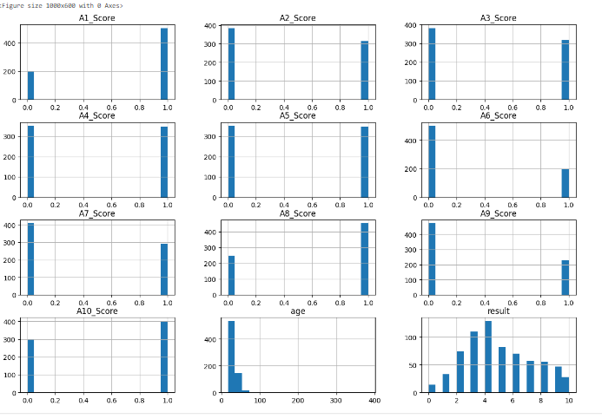

**RESULT:**

The programs for time series data cleaning, loading and handling time series data and pre-processing techniques on the autism screening dataset has been implemented successfully.